Faith Iyekeoretin-Obasogie
Software Developer
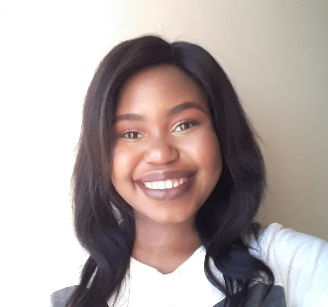 | DOB: 28-12-1999 | ID: 992281216082
59 Queens Road,  King Williams Town | Cell: 0766207510 | faith5fio@gmail.com
 | PERSONAL STATEMENT
Faith has a diploma and an advanced diploma in information technology (majoring in Software Development). She is competent in the following areas of software development: web development, mobile app development, games development, databases and project management. In addition, she has completed the Microsoft Azure Fundamentals certification that further advances her knowledge in basic cloud programming concepts. She pays good attention to details, is a good listener, works well teams, has good communication skills and work well under pressure. She looks forward to opportunities that challenge her and put her skills to the test.

 | EDUCATION
2021
Advanced Diploma Information Technology: Software Development •
Central University of Technology •
Key courses: SQL, Server administration (Microsoft Windows), Games development, Research project, Programming design patterns, Operating systems, Information security

2018 - 2020
Diploma Information Technology: Software Development (Cum Laude) •
Central University of Technology •
Key courses: SQL, Mobile app development (android), Web development (Html, CSS, ASP.NET MVC, JavaScript, Joomla), UX/UI design, Mathematics

2017
National Senior Certificate
Kingsridge High School For Girls •
Key Courses: English, Mathematics, Afrikaans, Visual Arts, Consumer Studies, Life Sciences, Life Orientation

 | SKILLS
General
- Microsoft Suite
- Good Problem Solving skills
- Good communication skills
- Detail Orientated
- Good listener
- Experience with GitHub
- Experience using Visual Studio, Android studio, Netbeans and Eclipse
- Experience using Vaadin platform
- Experience with Springboot

Programming Languages & frameworks
- C#
- ASP.Net MVC
- Java (Android)
- Html
- CSS
- SQL
- JavaScript

 | CERTIFICATIONS
Microsoft Azure Fundamentals (April 2021)
 | EXPERIENCE
Omega Computech
Position: General Worker
2022 – Present

 | HOBBIES
- Reading, drawing and painting, baking

